Sebastian Siqueiros
Module 2.2 Assignment

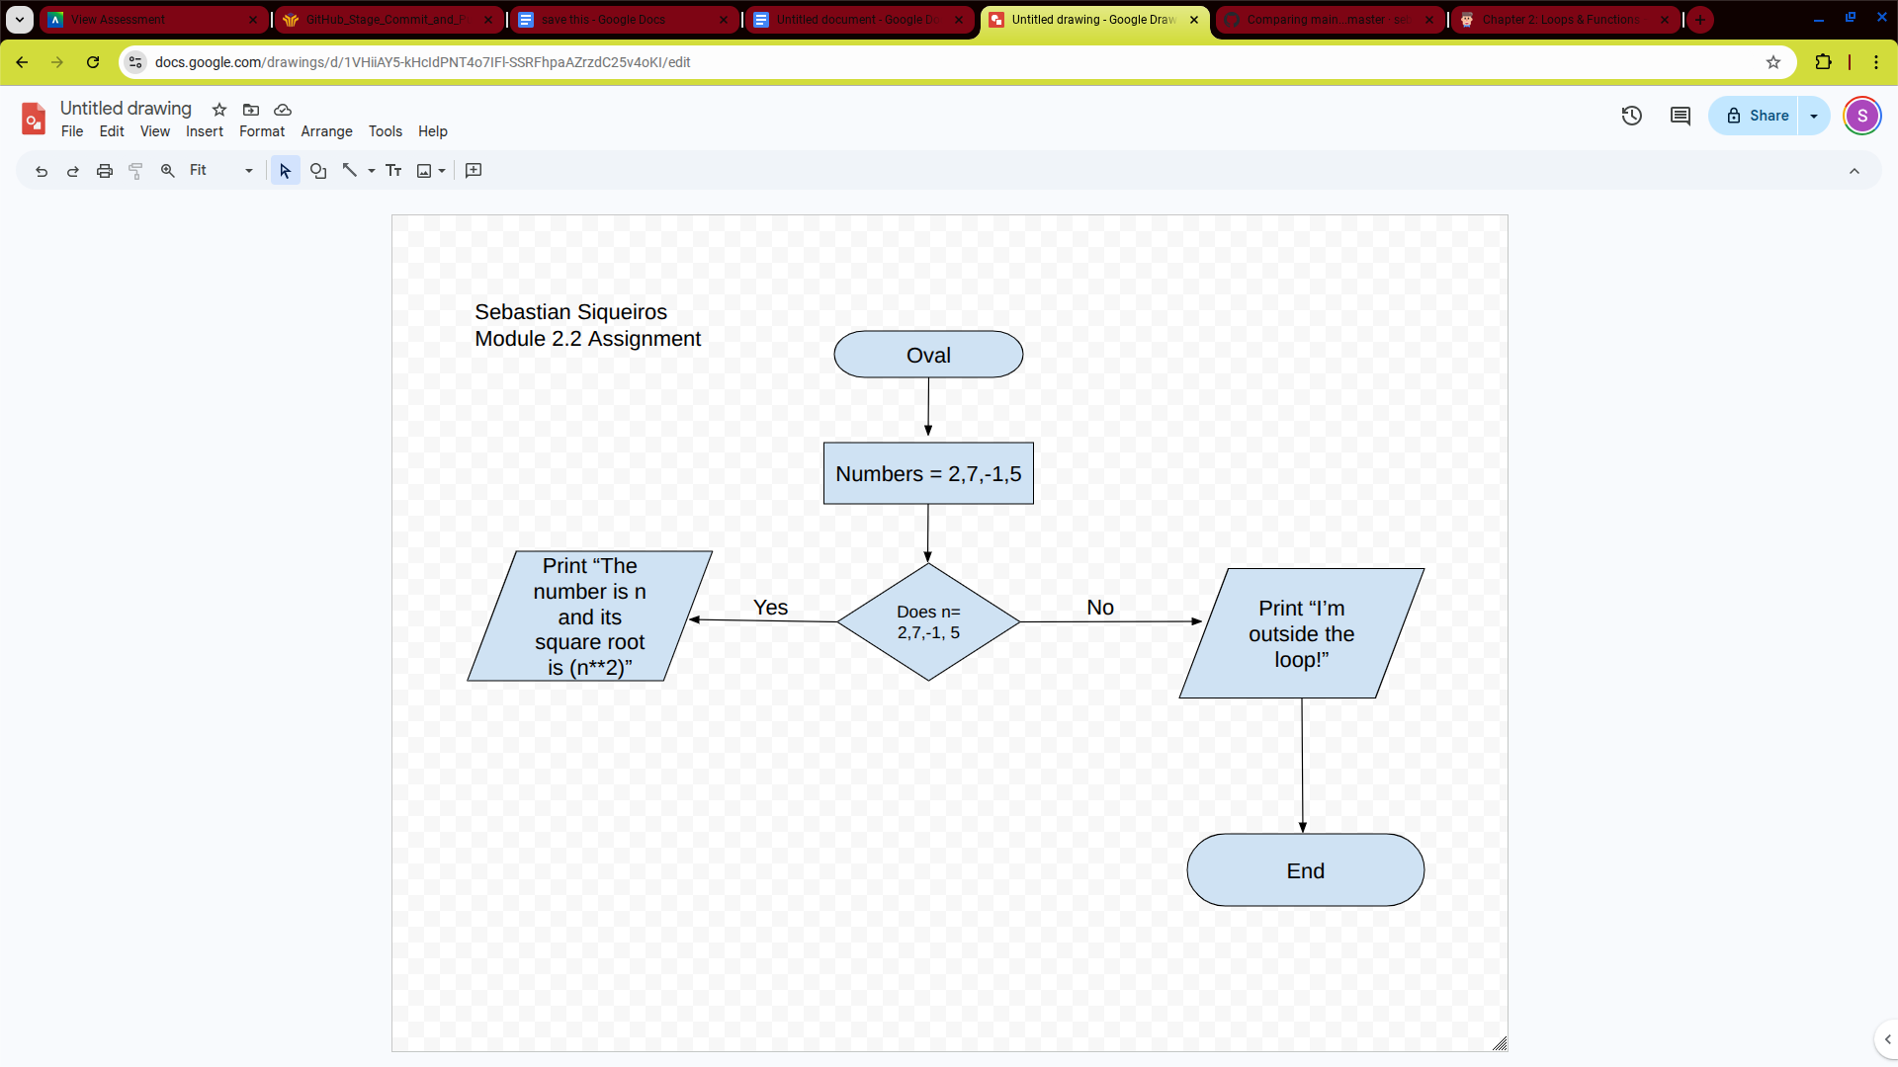

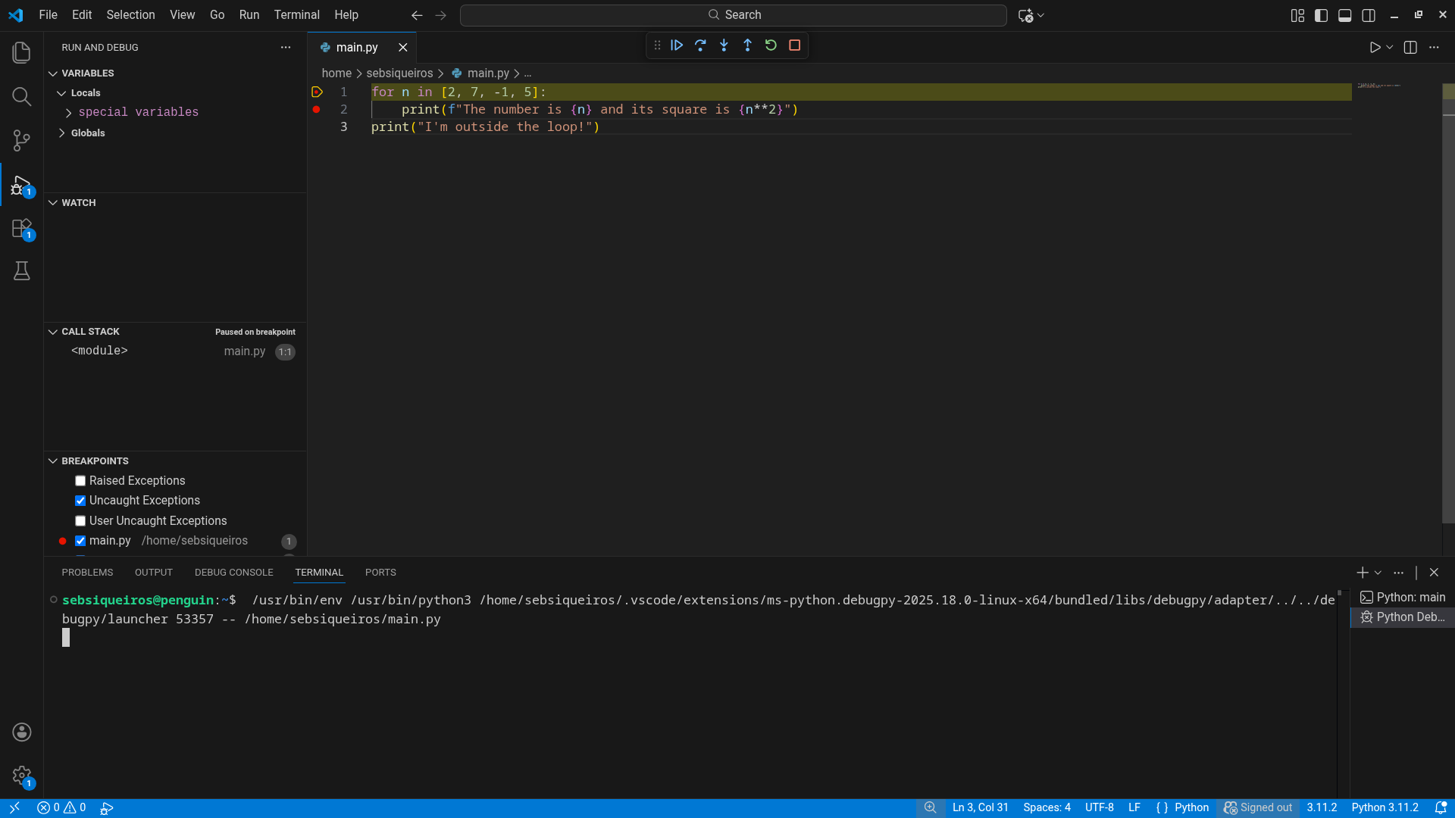

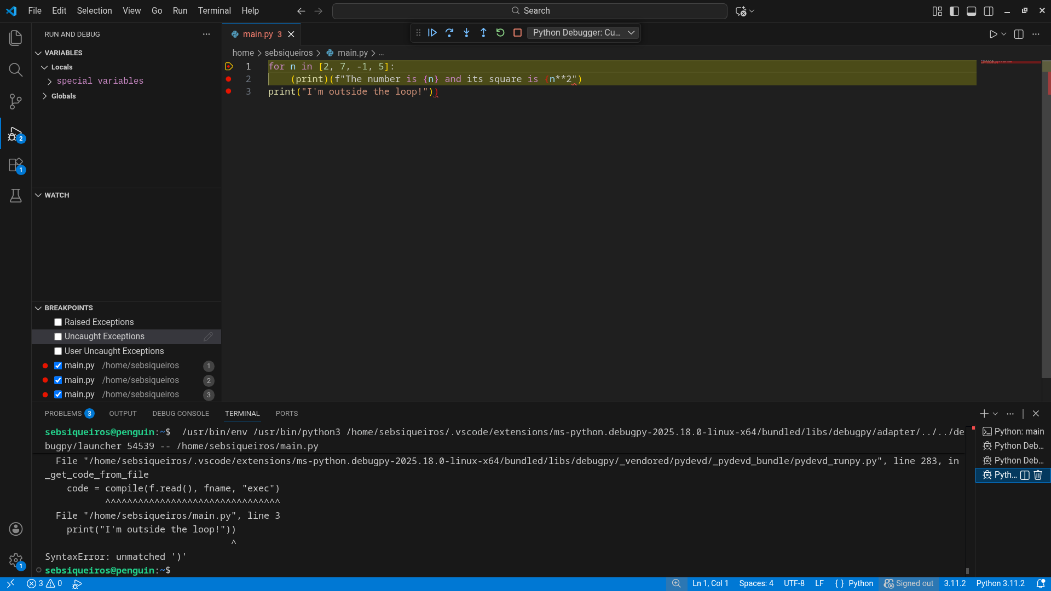

Reference For Code
P4yds. Python Programing For Data Science. https://www.tomasbeuzen.com/python-programming-for-data-science/chapters/chapter2-loops-functions.html

